

In Edite we can add to install all cliend system



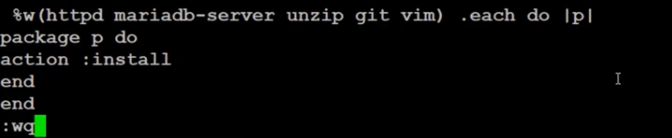

Upload it



Git is installed in cliend system

